Assignment EFS -02: QUANTITATIVE STRATEGY MODELING IN EXCEL
Note: If there are multiple files for the assignment, please zip all the files in .zip format.
Submitted By: Nicholas Burgess
Question: Make sure that you complete the model discussed in the class and work on the data as provided in the “In_Class_EFS-02_File” which was used in class. Check the sheet “Desired Output”. You have to calculate following values using various excel formulas discussed in the class:

Number of Long Signals | 225
Number of Short Signals | 181
Total number of Signals | 406
Number of Long Signals Traded | 5
Number of Short Signals Traded | 4
Total number of Signals Traded | 9
Number of Profitable Trades | 4
Number of Loss Making Trades | 5
Profit from Profitable Trades | 262.26
Loss from loss making trades | -57.24
Total Profit | 205.03
Average Number of Signals per Trading Hour | 13.98
Average Number of Trades per Trading Hour | 0.31
Average Holding Period of a Trade (in minutes) | 192
Maximum Profit from a trade | 69.56
Maximum Loss from a trade | -11.85
Average Profit (or Loss) Per Trade | 22.78
Assumed Slippage (assume a value) | 1.00%
Brokerage (assume a value) | 2.00%
Net Profit per trade after costs | 22.10
Total Net Profit after costs | 198.88

- Make sure that you are not doing these calculations manually. All computations need to be done using excel formulas.
- Upload your final model along with completed table of values.
- Note: If there is more than one file kindly zip it in .zip format.

What If Analysis: Total Profit for Varied Levels of Stop Loss and Take Profit Triggers
A What If analysis gave best results for a stop loss (SL) and take profit (TP) parameters of 1 and 6 respectively.

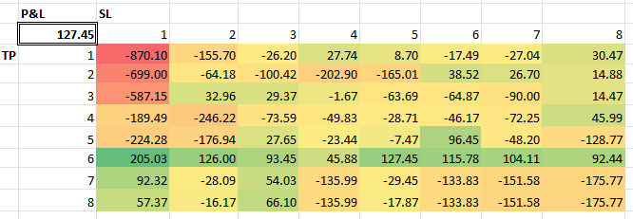

Trading Strategy Results Summary
Using optimal stop loss and take profit parameters, where SL=1 and TP=6.

