How to Run the Code on Your Local Computer?

The procedure to run the code on IBridgePy on your computer is as follows:

- The Python file containing your strategy code must be saved inside the “Strategies” folder. In this illustration, the code you want to run is “strategy_file.py” which is placed inside the “Strategies” folder.
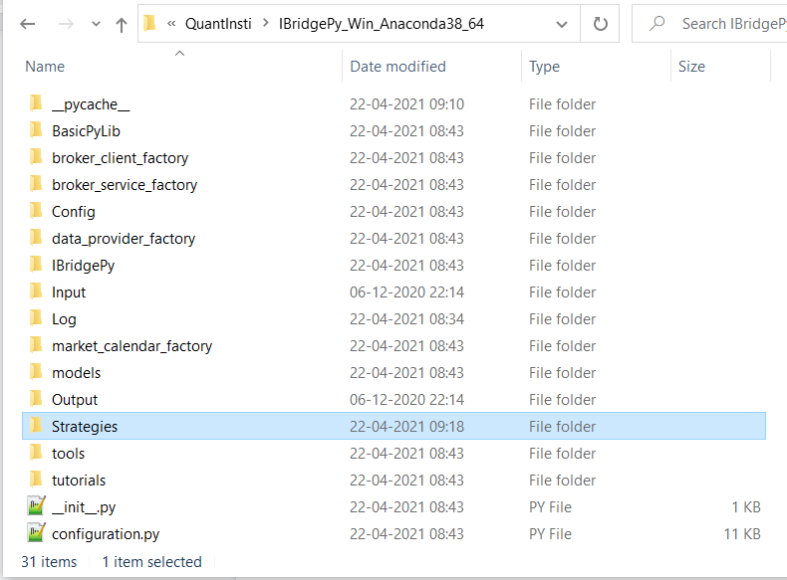
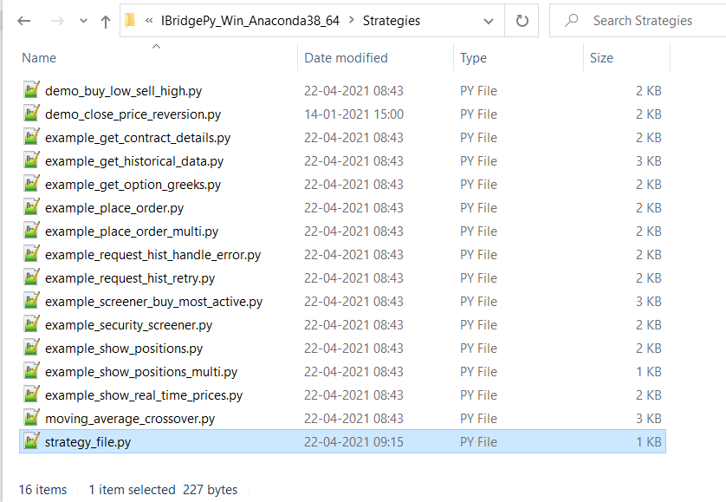
- Open the “RUN_ME.py” file in the IBridgePy folder.
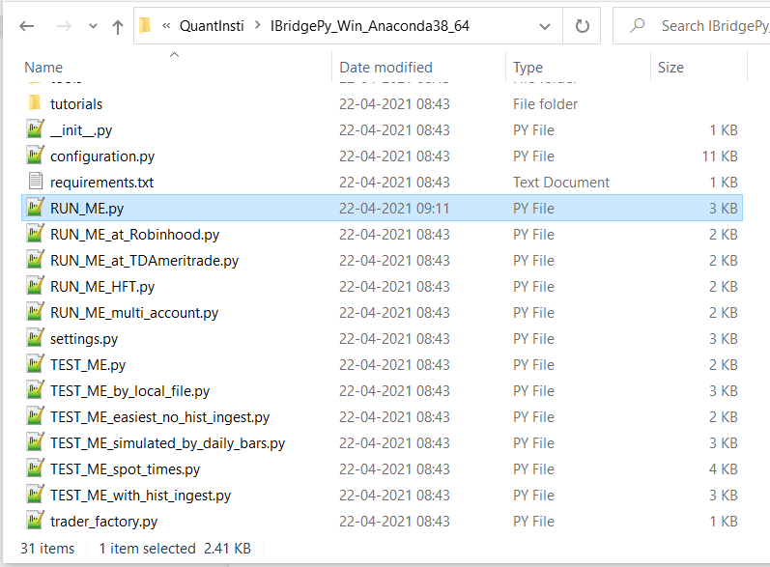
- You have to edit the “RUN_ME.py” file in two places:
  - The “filename” variable must have the name of the strategy file that you want to run.
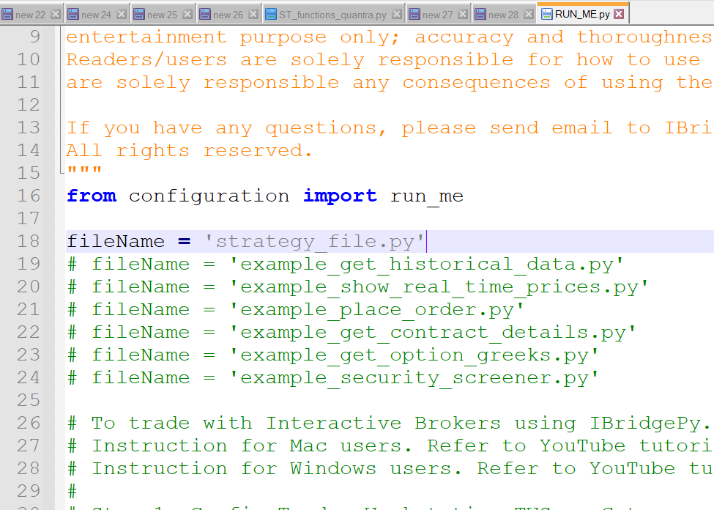
  - The “accountCode” value must be changed to your IB account code. The account code can be seen in the top right portion of the IB TWS window.
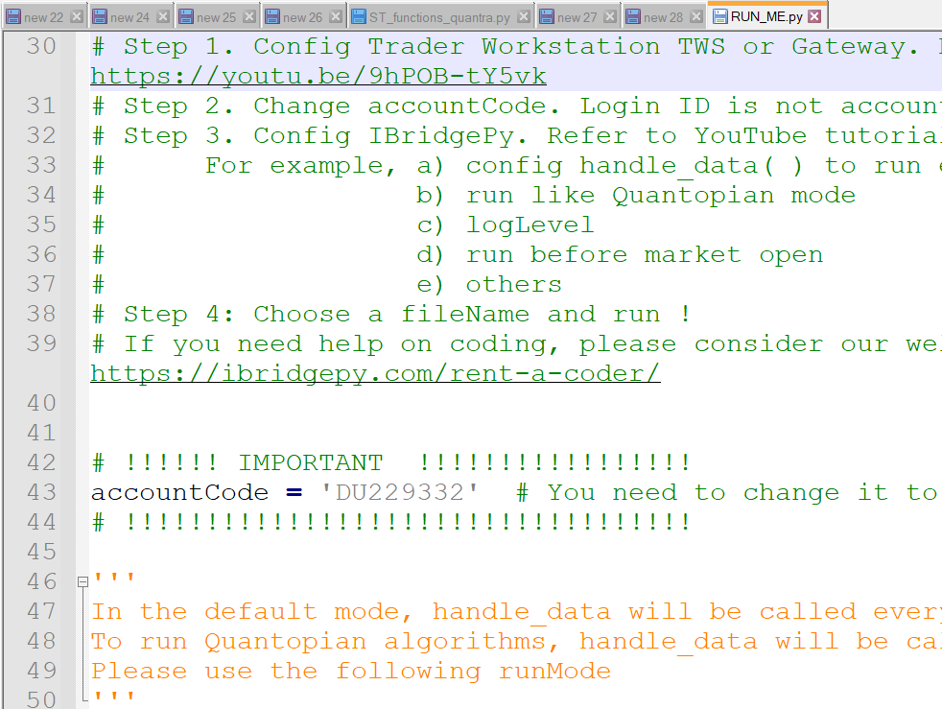
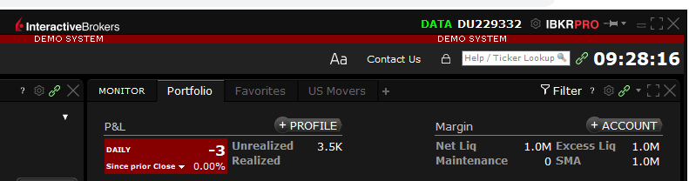
- After the configuration of the “RUN_ME.py” file, and the placement of the strategy code in the “Strategies” folder, open the Python terminal and browse to the IBridgePy folder.
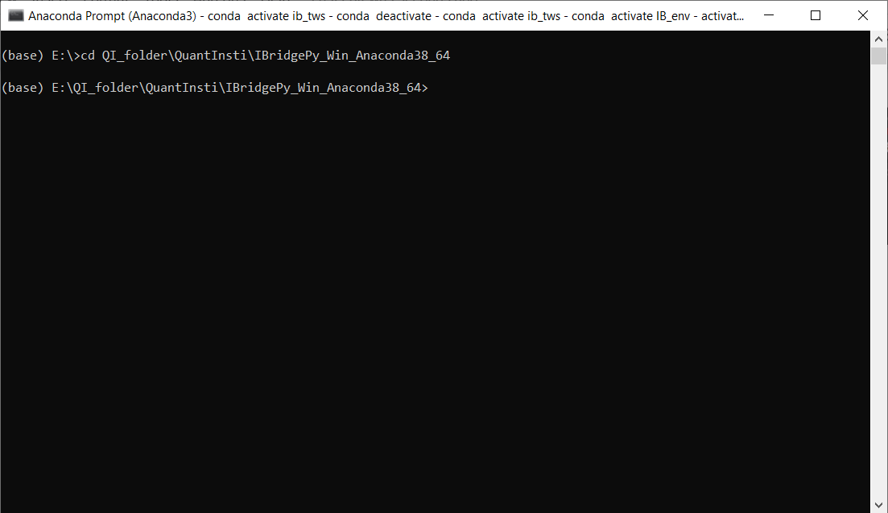
- We are now ready to run the strategy file! Type the following code in the terminal: python RUN_ME.py
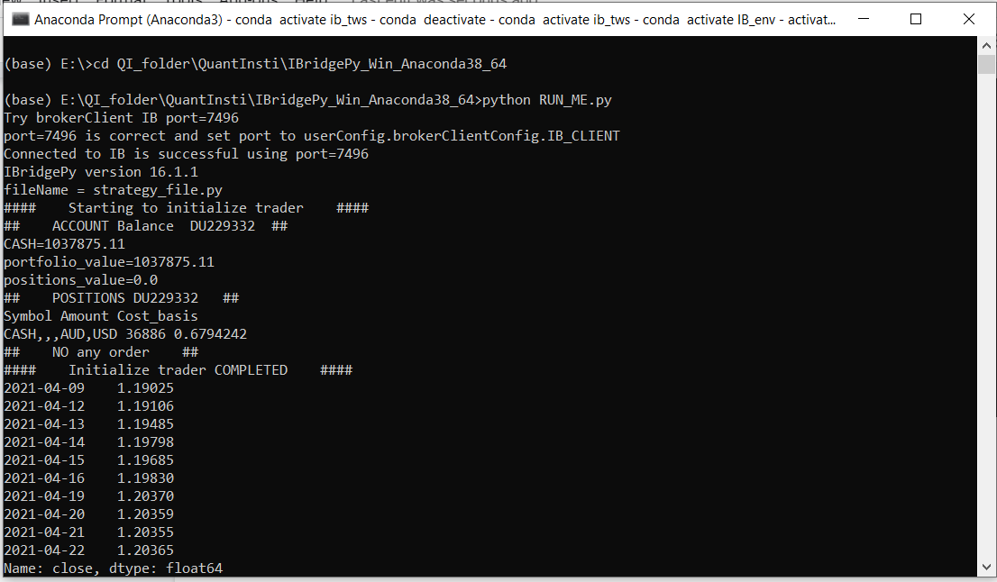
That’s all! IBridgePy will then connect to the broker and run your code. You can follow these steps to run other strategy files using IBridgePy. Just replace “strategy_file.py” with the name of the file you want to run and repeat the above steps.

