J（Θ） common
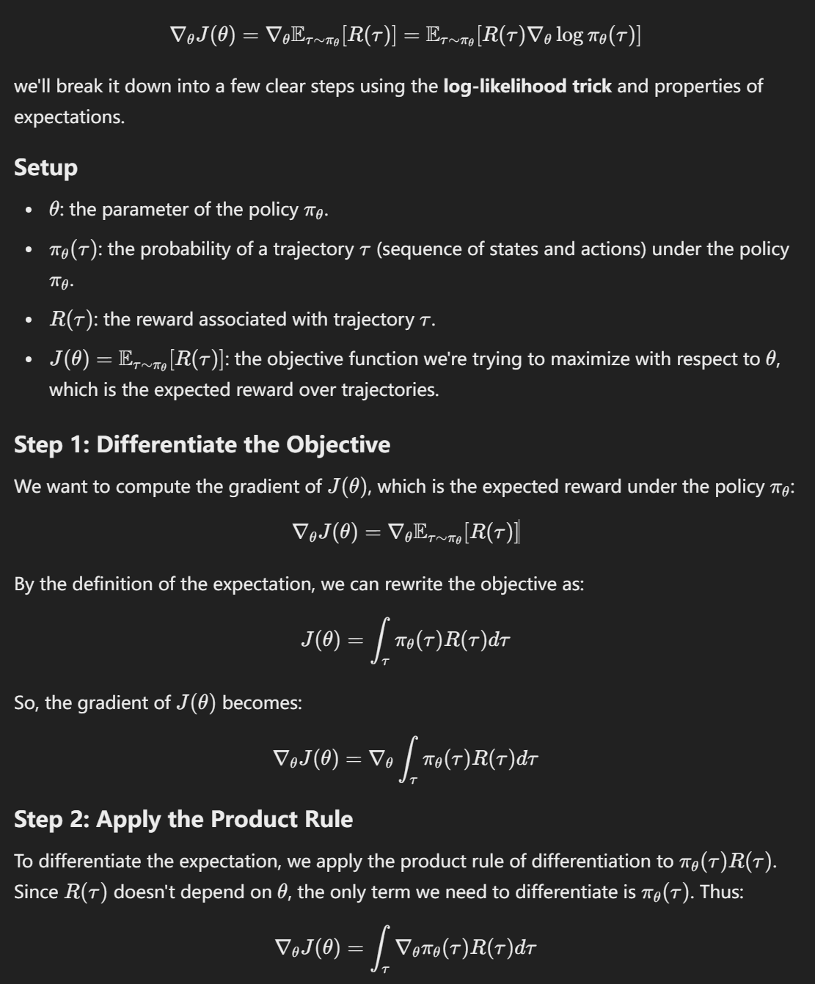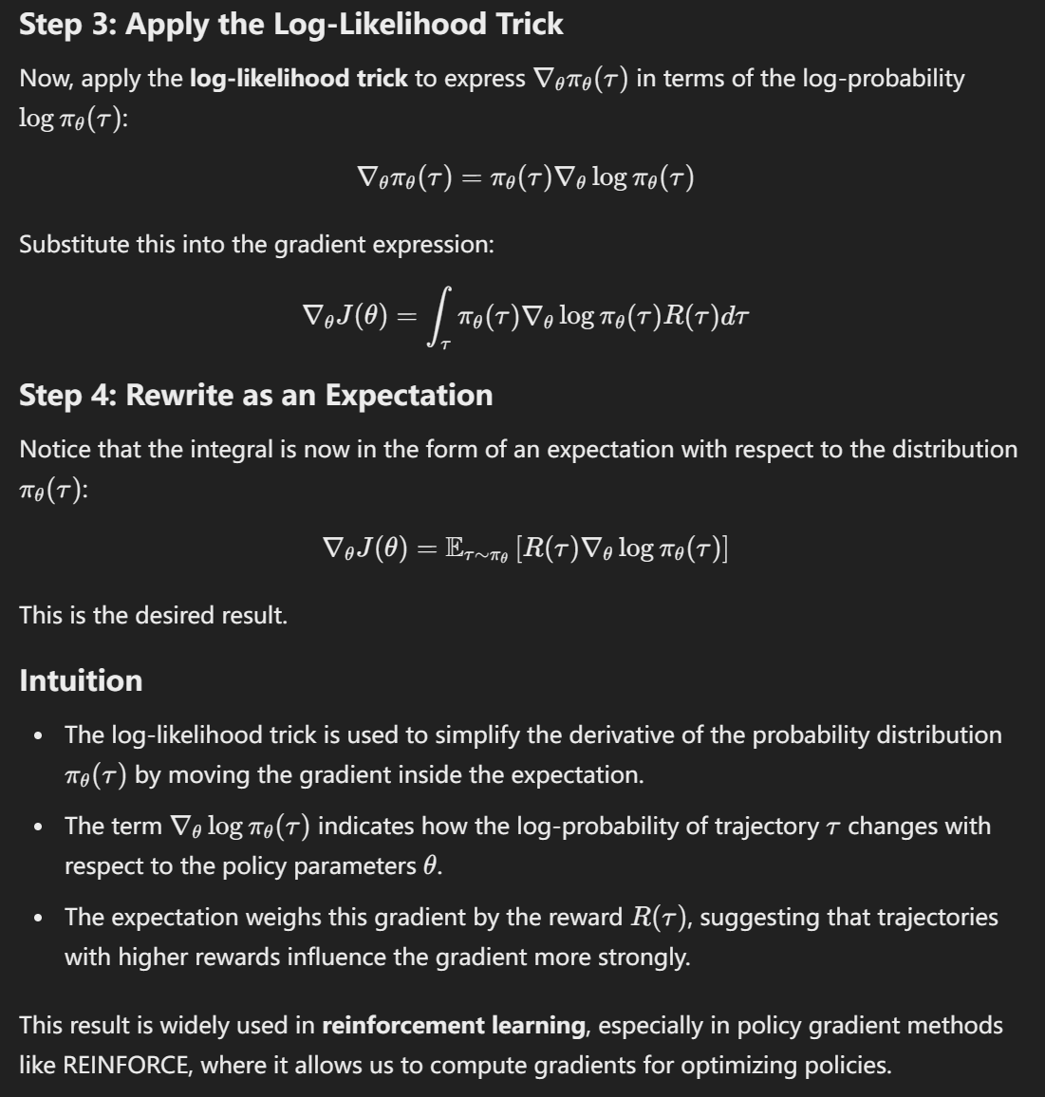

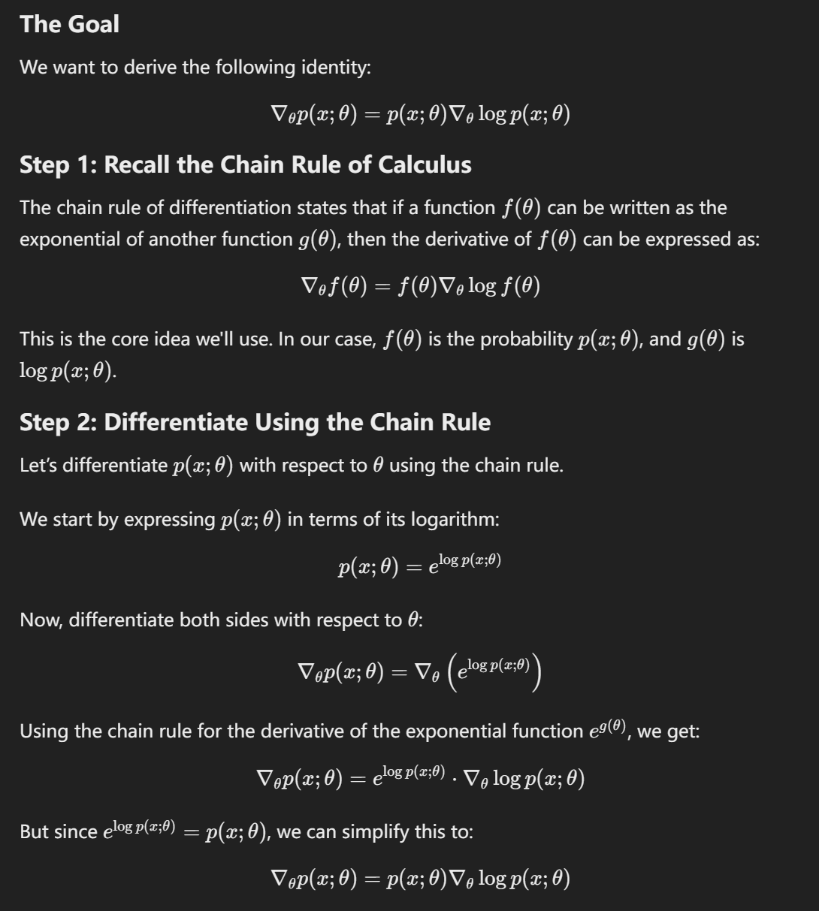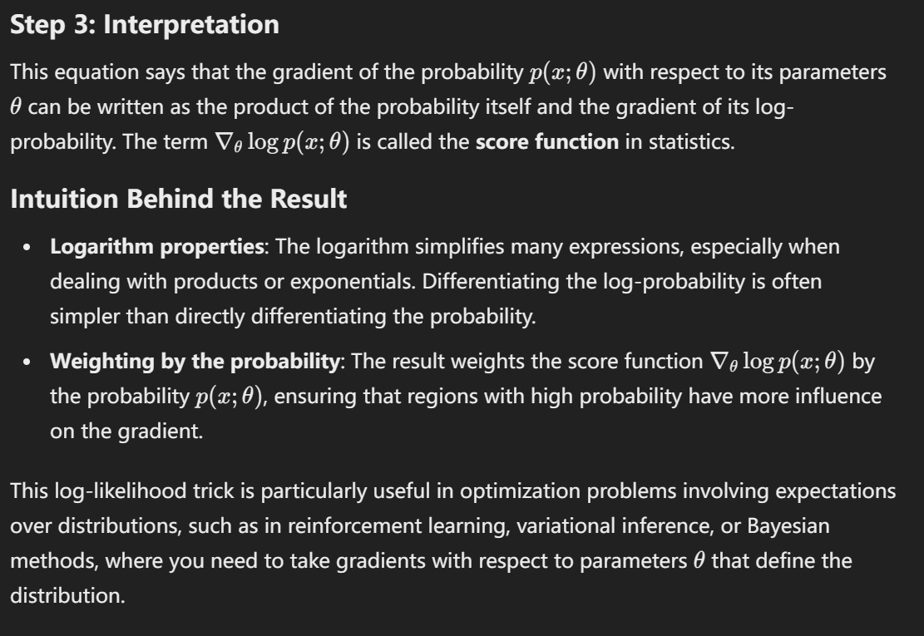

JΘ reinenforce learning
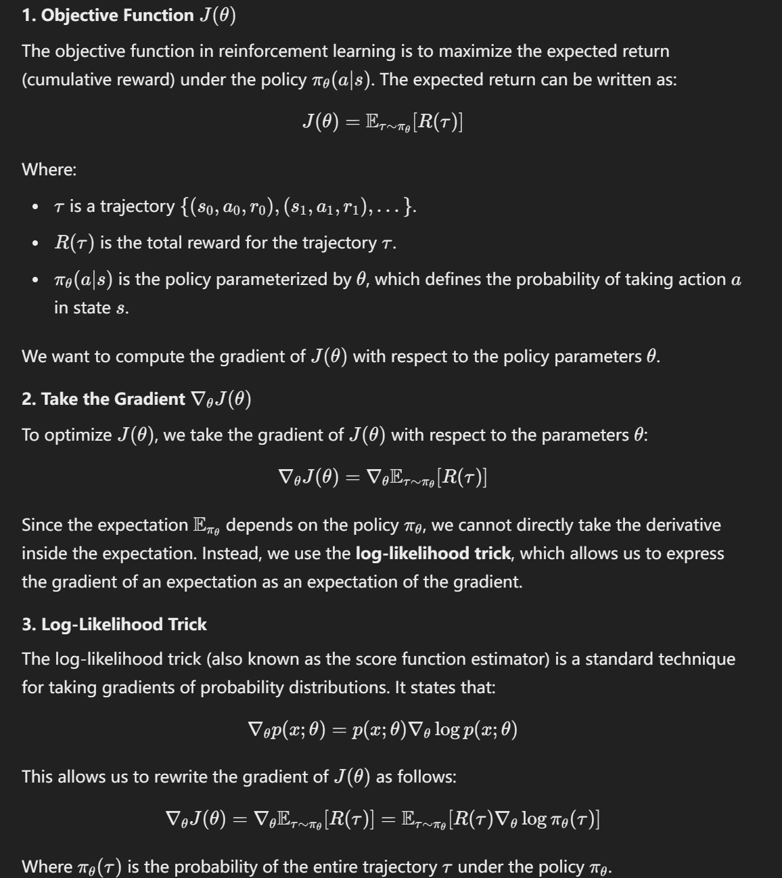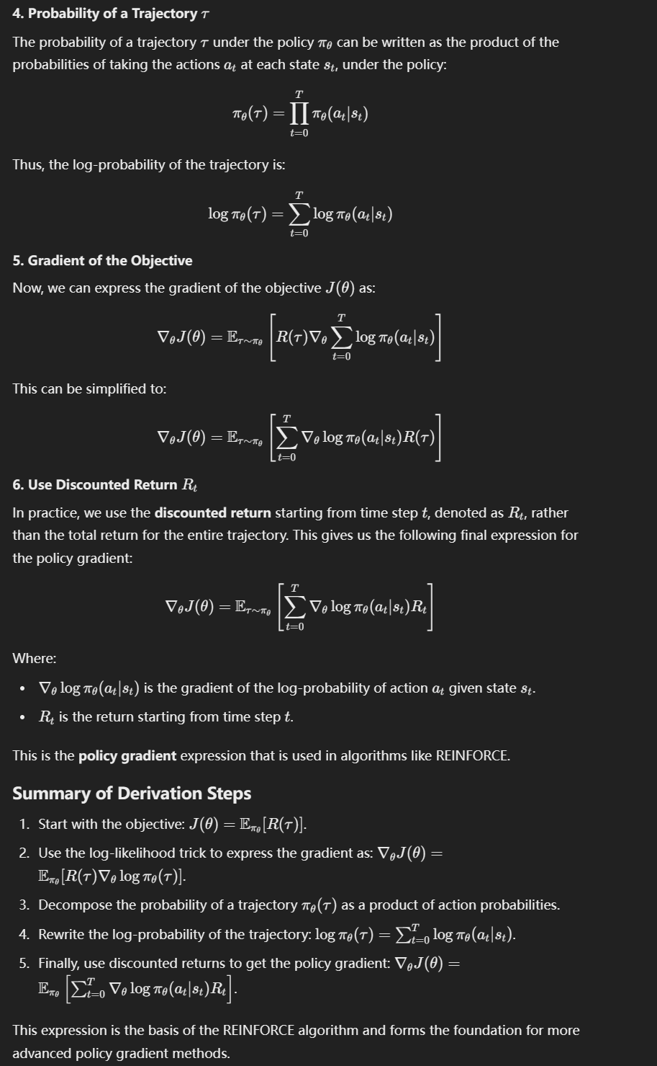

Policy Gradient method for reinenforce learning

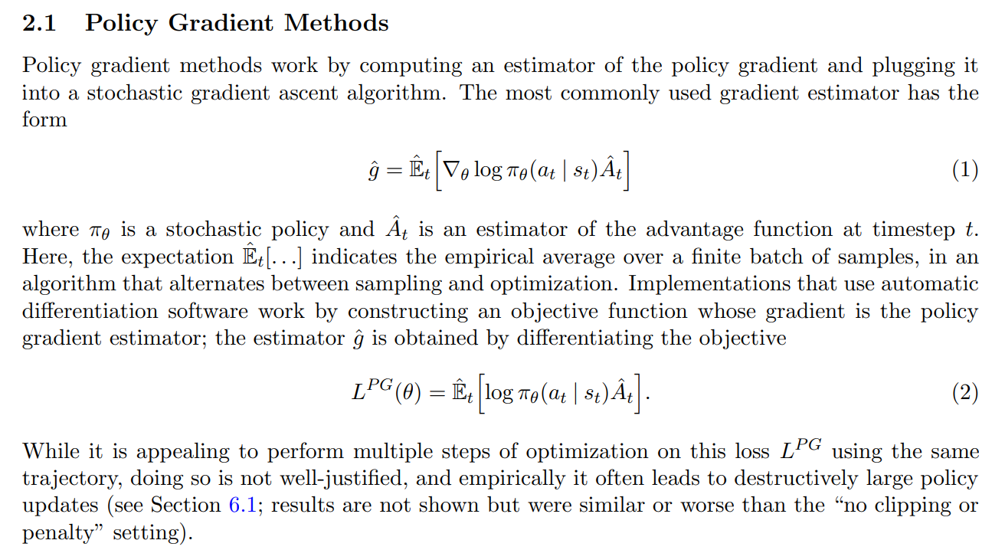

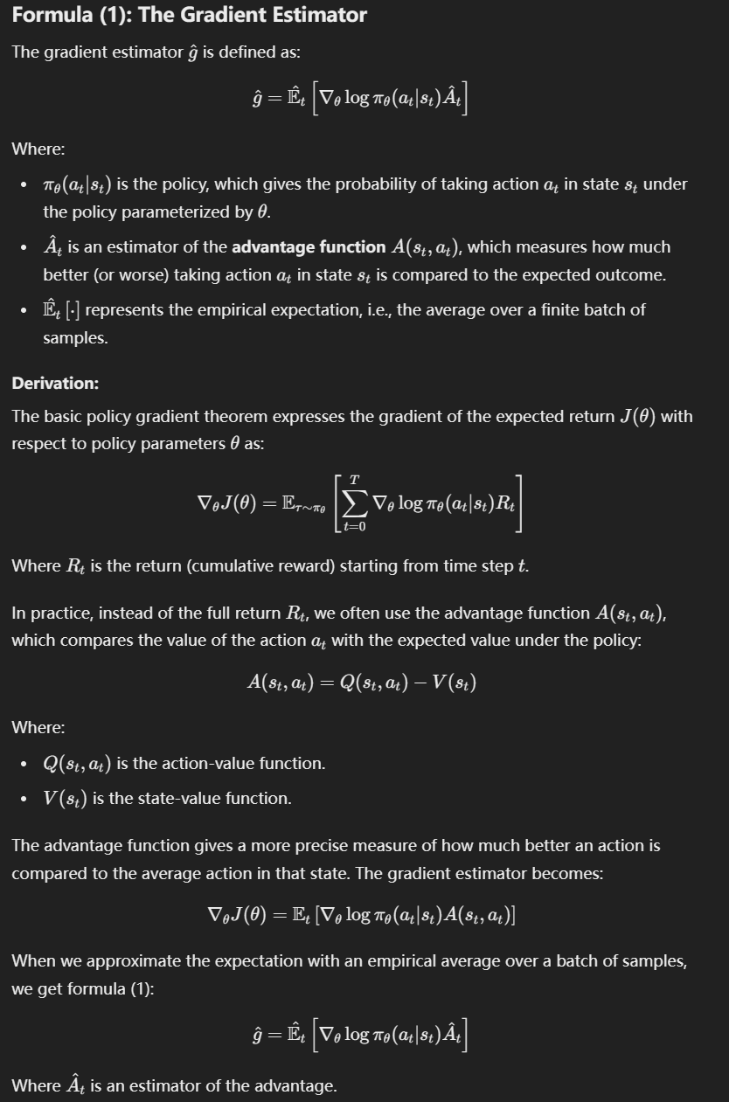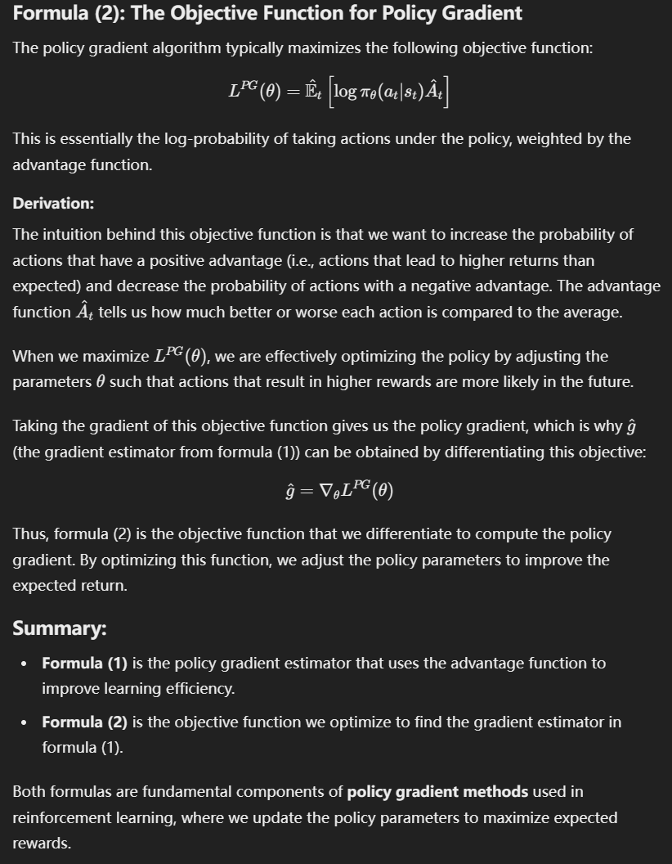

PPO
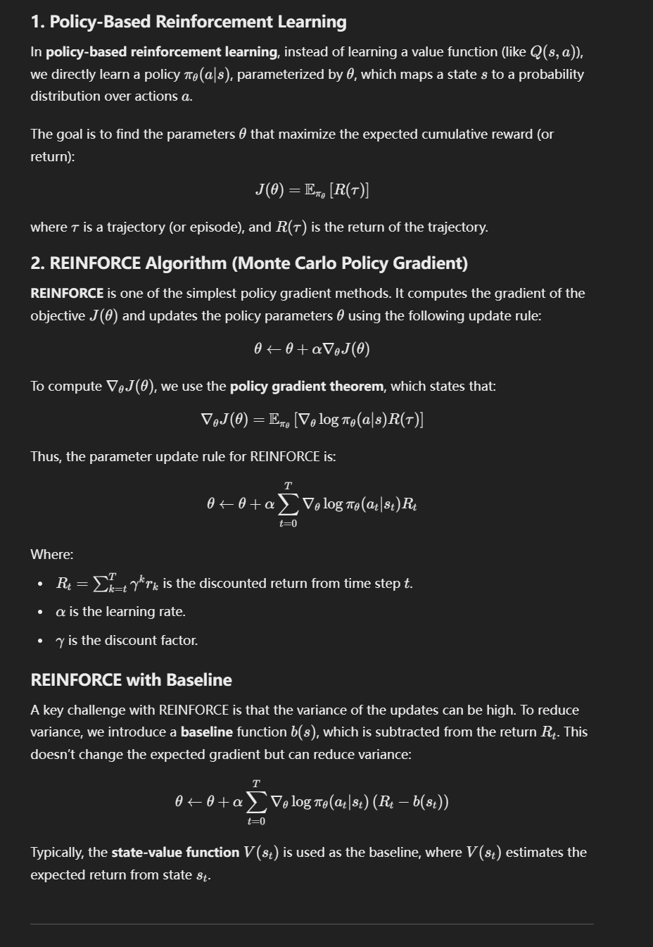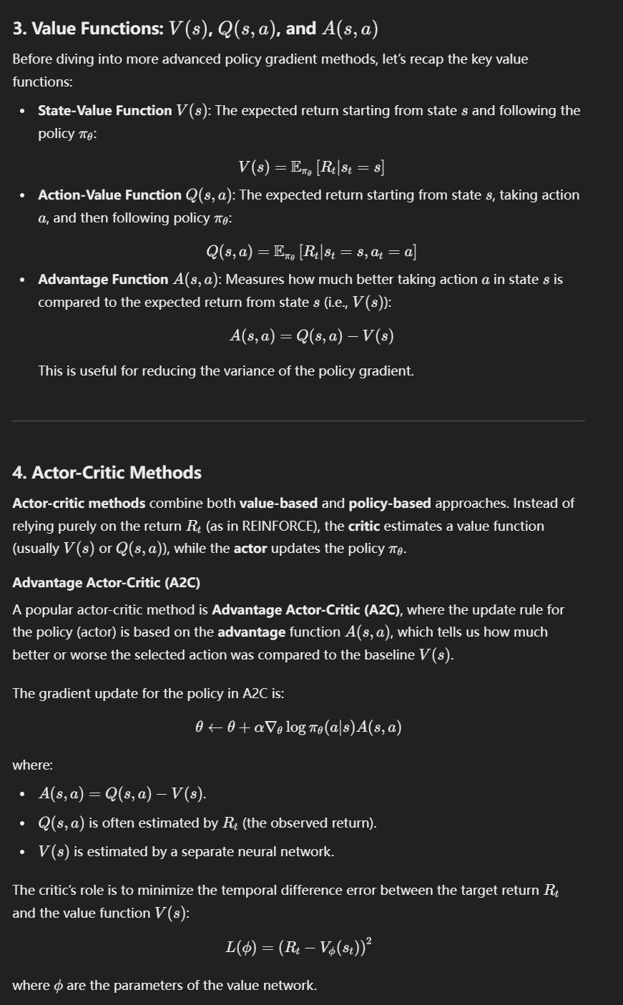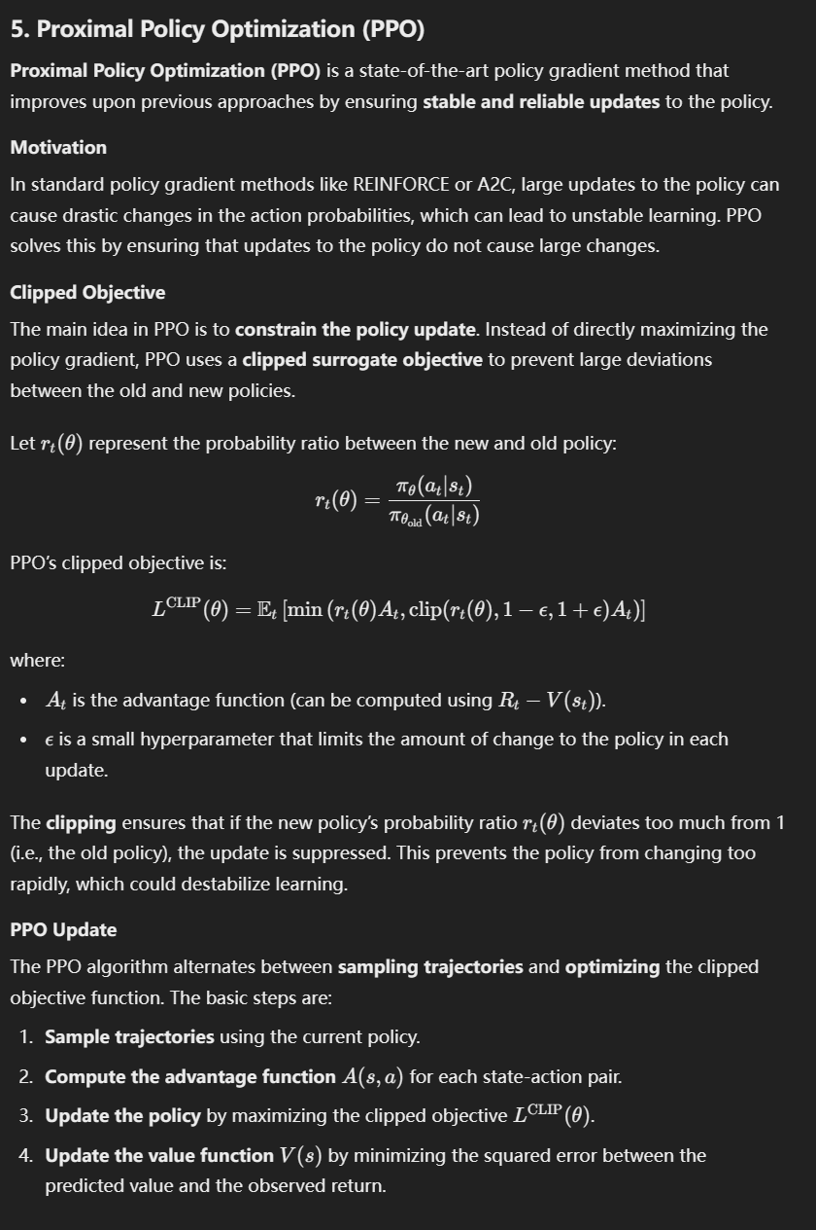

Proximal Policy Optimization (PPO) is a popular policy gradient method in reinforcement learning, designed to improve training stability and efficiency. It involves two key techniques:
- Clipped Surrogate Objective: PPO restricts the update size for the policy by using a clipped version of the probability ratio between the old and new policy.
- Multiple Updates per Trajectory: Instead of updating the policy after each experience, PPO allows for multiple updates using the same set of trajectories, but carefully controls how far the policy can change.

# Initialize policy network pi_theta and value network V_phi
policy_network = PolicyNetwork() # pi_theta
value_network = ValueNetwork() # V_phi
optimizer_policy = Optimizer(policy_network.parameters)
optimizer_value = Optimizer(value_network.parameters)

# Hyperparameters
epsilon = 0.2 # Clipping range for PPO
epochs = 10 # Number of policy updates per trajectory
gamma = 0.99 # Discount factor
lambda_gae = 0.95 # GAE (Generalized Advantage Estimation) factor
batch_size = 64 # Minibatch size for updates
max_steps_per_episode = 1000 # Maximum steps per episode

for episode in range(total_episodes):

# 1. Collect trajectories from the current policy pi_theta
states, actions, rewards, log_probs_old, values = collect_trajectories(policy_network, value_network)

# 2. Compute discounted rewards (returns) and advantages using GAE
returns, advantages = compute_advantages(rewards, values, gamma, lambda_gae)

for _ in range(epochs):
# 3. Shuffle trajectories and sample minibatches
for batch in minibatch(states, actions, log_probs_old, returns, advantages, batch_size):

# Extract data for this batch
batch_states, batch_actions, batch_log_probs_old, batch_returns, batch_advantages = batch

# 4. Compute new log-probs, entropy, and state values
log_probs_new, entropy = policy_network.evaluate_actions(batch_states, batch_actions)
values_pred = value_network(batch_states).squeeze()

# 5. Compute ratio of new and old probabilities
ratio = exp(log_probs_new - batch_log_probs_old) # pi_theta(a|s) / pi_old(a|s)

# 6. Calculate the clipped surrogate objective (policy loss)
unclipped_objective = ratio * batch_advantages
clipped_objective = clip(ratio, 1 - epsilon, 1 + epsilon) * batch_advantages
policy_loss = -mean(min(unclipped_objective, clipped_objective)) # Minimize the negative objective

# 7. Compute value loss (mean squared error)
value_loss = mean((batch_returns - values_pred) ** 2)

# 8. Update policy and value networks
optimizer_policy.zero_grad()
policy_loss.backward()
optimizer_policy.step()

optimizer_value.zero_grad()
value_loss.backward()
optimizer_value.step()

# 9. Optionally log episode results (rewards, losses, etc.)
log_episode_results(episode, rewards, policy_loss, value_loss)
